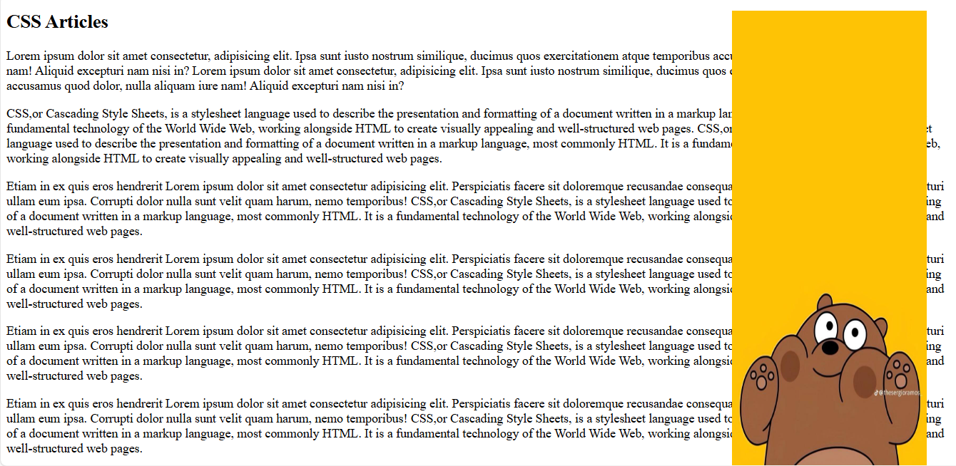

<!DOCTYPE html>
<html lang="en">
<head>
<meta charset="UTF-8">

<style>

img {
position: absolute;
right: 40px;
top: 20px;
width: 245px;
height: 650px;;
}

/* يمنع أي نص من الالتفاف حول الصورة */
.clearfix {
clear: both;
}

</style>

</head>
<body>

<!-- الصورة -->
<img src="images/sheh.jpg">

<!-- هذا السطر مهم جداً لتبدأ كل النصوص من تحت الصورة -->
<div class="clearfix"></div>

<h2>CSS Articles</h2>

<div class="box box1">
<p>
Lorem ipsum dolor sit amet consectetur, adipisicing elit.
Ipsa sunt iusto nostrum similique,
ducimus quos exercitationem atque
temporibus accusamus quod dolor,
nulla aliquam iure nam!
Aliquid excepturi nam nisi in?

Lorem ipsum dolor sit amet consectetur, adipisicing elit.
Ipsa sunt iusto nostrum similique,
ducimus quos exercitationem atque
temporibus accusamus quod dolor,
nulla aliquam iure nam!
Aliquid excepturi nam nisi in?
</p>
</div>

<div class="box box2">
<p>
CSS,or Cascading Style Sheets, is a stylesheet language
used to describe the presentation and formatting of a document written
in a markup language, most commonly HTML. It is a fundamental technology
of the World Wide Web, working alongside HTML to create visually appealing
and well-structured web pages.

CSS,or Cascading Style Sheets, is a stylesheet language
used to describe the presentation and formatting of a document written
in a markup language, most commonly HTML. It is a fundamental technology
of the World Wide Web, working alongside HTML to create visually appealing
and well-structured web pages.
</p>
</div>

<div class="box box3">
<p>
Etiam in ex quis eros hendrerit
Lorem ipsum dolor sit amet consectetur adipisicing elit.
Perspiciatis facere sit doloremque recusandae consequatur,
maxime similique, expedita excepturi ullam eum ipsa.
Corrupti dolor nulla sunt velit quam harum, nemo temporibus!
CSS,or Cascading Style Sheets, is a stylesheet language
used to describe the presentation and formatting of a document written
in a markup language, most commonly HTML. It is a fundamental technology
of the World Wide Web, working alongside HTML to create visually appealing
and well-structured web pages.
</p>

<p>
Etiam in ex quis eros hendrerit
Lorem ipsum dolor sit amet consectetur adipisicing elit.
Perspiciatis facere sit doloremque recusandae consequatur,
maxime similique, expedita excepturi ullam eum ipsa.
Corrupti dolor nulla sunt velit quam harum, nemo temporibus!
CSS,or Cascading Style Sheets, is a stylesheet language
used to describe the presentation and formatting of a document written
in a markup language, most commonly HTML. It is a fundamental technology
of the World Wide Web, working alongside HTML to create visually appealing
and well-structured web pages.
</p>

<p>
Etiam in ex quis eros hendrerit
Lorem ipsum dolor sit amet consectetur adipisicing elit.
Perspiciatis facere sit doloremque recusandae consequatur,
maxime similique, expedita excepturi ullam eum ipsa.
Corrupti dolor nulla sunt velit quam harum, nemo temporibus!
CSS,or Cascading Style Sheets, is a stylesheet language
used to describe the presentation and formatting of a document written
in a markup language, most commonly HTML. It is a fundamental technology
of the World Wide Web, working alongside HTML to create visually appealing
and well-structured web pages.
</p>

<p>
Etiam in ex quis eros hendrerit
Lorem ipsum dolor sit amet consectetur adipisicing elit.
Perspiciatis facere sit doloremque recusandae consequatur,
maxime similique, expedita excepturi ullam eum ipsa.
Corrupti dolor nulla sunt velit quam harum, nemo temporibus!
CSS,or Cascading Style Sheets, is a stylesheet language
used to describe the presentation and formatting of a document written
in a markup language, most commonly HTML. It is a fundamental technology
of the World Wide Web, working alongside HTML to create visually appealing
and well-structured web pages.
</p>

<p>
Etiam in ex quis eros hendrerit
Lorem ipsum dolor sit amet consectetur adipisicing elit.
Perspiciatis facere sit doloremque recusandae consequatur,
maxime similique, expedita excepturi ullam eum ipsa.
Corrupti dolor nulla sunt velit quam harum, nemo temporibus!
CSS,or Cascading Style Sheets, is a stylesheet language
used to describe the presentation and formatting of a document written
in a markup language, most commonly HTML. It is a fundamental technology
of the World Wide Web, working alongside HTML to create visually appealing
and well-structured web pages.
</p>

</div>

</body>
</html>

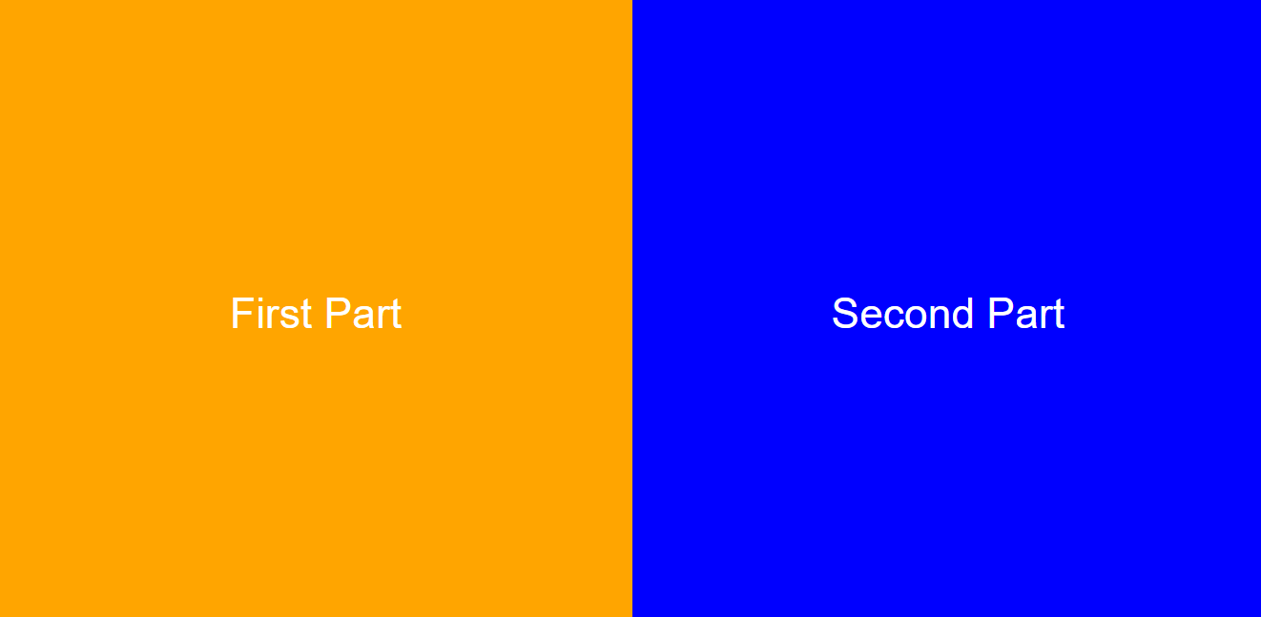

<!DOCTYPE html>
<html lang="en">
<head>
<meta charset="UTF-8">
<style>

.container {
display: flex;
height: 100vh; /* يغطي كامل الشاشة */
}

.left, .right {
flex: 1; /* كل جزء يأخذ نصف الصفحة */
display: flex;
justify-content: center; /* توسيط أفقي */
align-items: center; /* توسيط عمودي */
font-size: 40px;
color: white;
font-family: Arial;
}

.left {
background: orange;
}

.right {
background: blue;
}

</style>
</head>

<body>

<div class="container">
<div class="left">First Part</div>
<div class="right">Second Part</div>
</div>

</body>
</html>


<!DOCTYPE html>
<html lang="en">
<head>
<meta charset="UTF-8">

<style>

.container {
display: flex; /* يخلي الصور جنب بعض */
flex-wrap: wrap; /* يخليهم ينزلوا تحت لما يخلص السطر */
gap: 15px; /* مسافة بين الصور */
}

.container img {
width: 230px; /* حجم الصور */
height: 150px;
object-fit: cover; /* قص ذكي حتى ما تتشوه الصورة */
border-radius: 10px; /* تدوير بسيط (اختياري) */
}

</style>

</head>

<body>

<div class="container">

<img src="images/cats.jpg">
<img src="images/dogs.jpg">
<img src="images/download (38).jpg">
<img src="images/horse.jpg">
<img src="images/sheh.jpg">
<img src="images/sea-waves.jpg">
<img src="images/sheha.jpg">
<img src="images/shehabg.jpg">
<img src="images/sea.jpg">

</div>

</body>
</html>

